**Stress Learning Games**

**Iteration 3**

* Team members and roles
  + Hanyang Li (Product Owner)
  + Ping Lu (Scrum Master and Game Testing)
  + Xin Hu (Programmer)
  + Zhiyu Yan (Programmer)
  + Chaoyang Zhu (Game Design)
  + Yipeng Lu (Programmer)
  + Mufeng Xie (Report Editor)
* Project Results so far:

The detailed programming codes can be found here:

<https://github.com/pinglu0212/2020-Spring-CSCE-606>

1. We have implemented the hangman game with stress learning theme according to the requirement of the customer. A sample screen shot of the game is illustrated below.

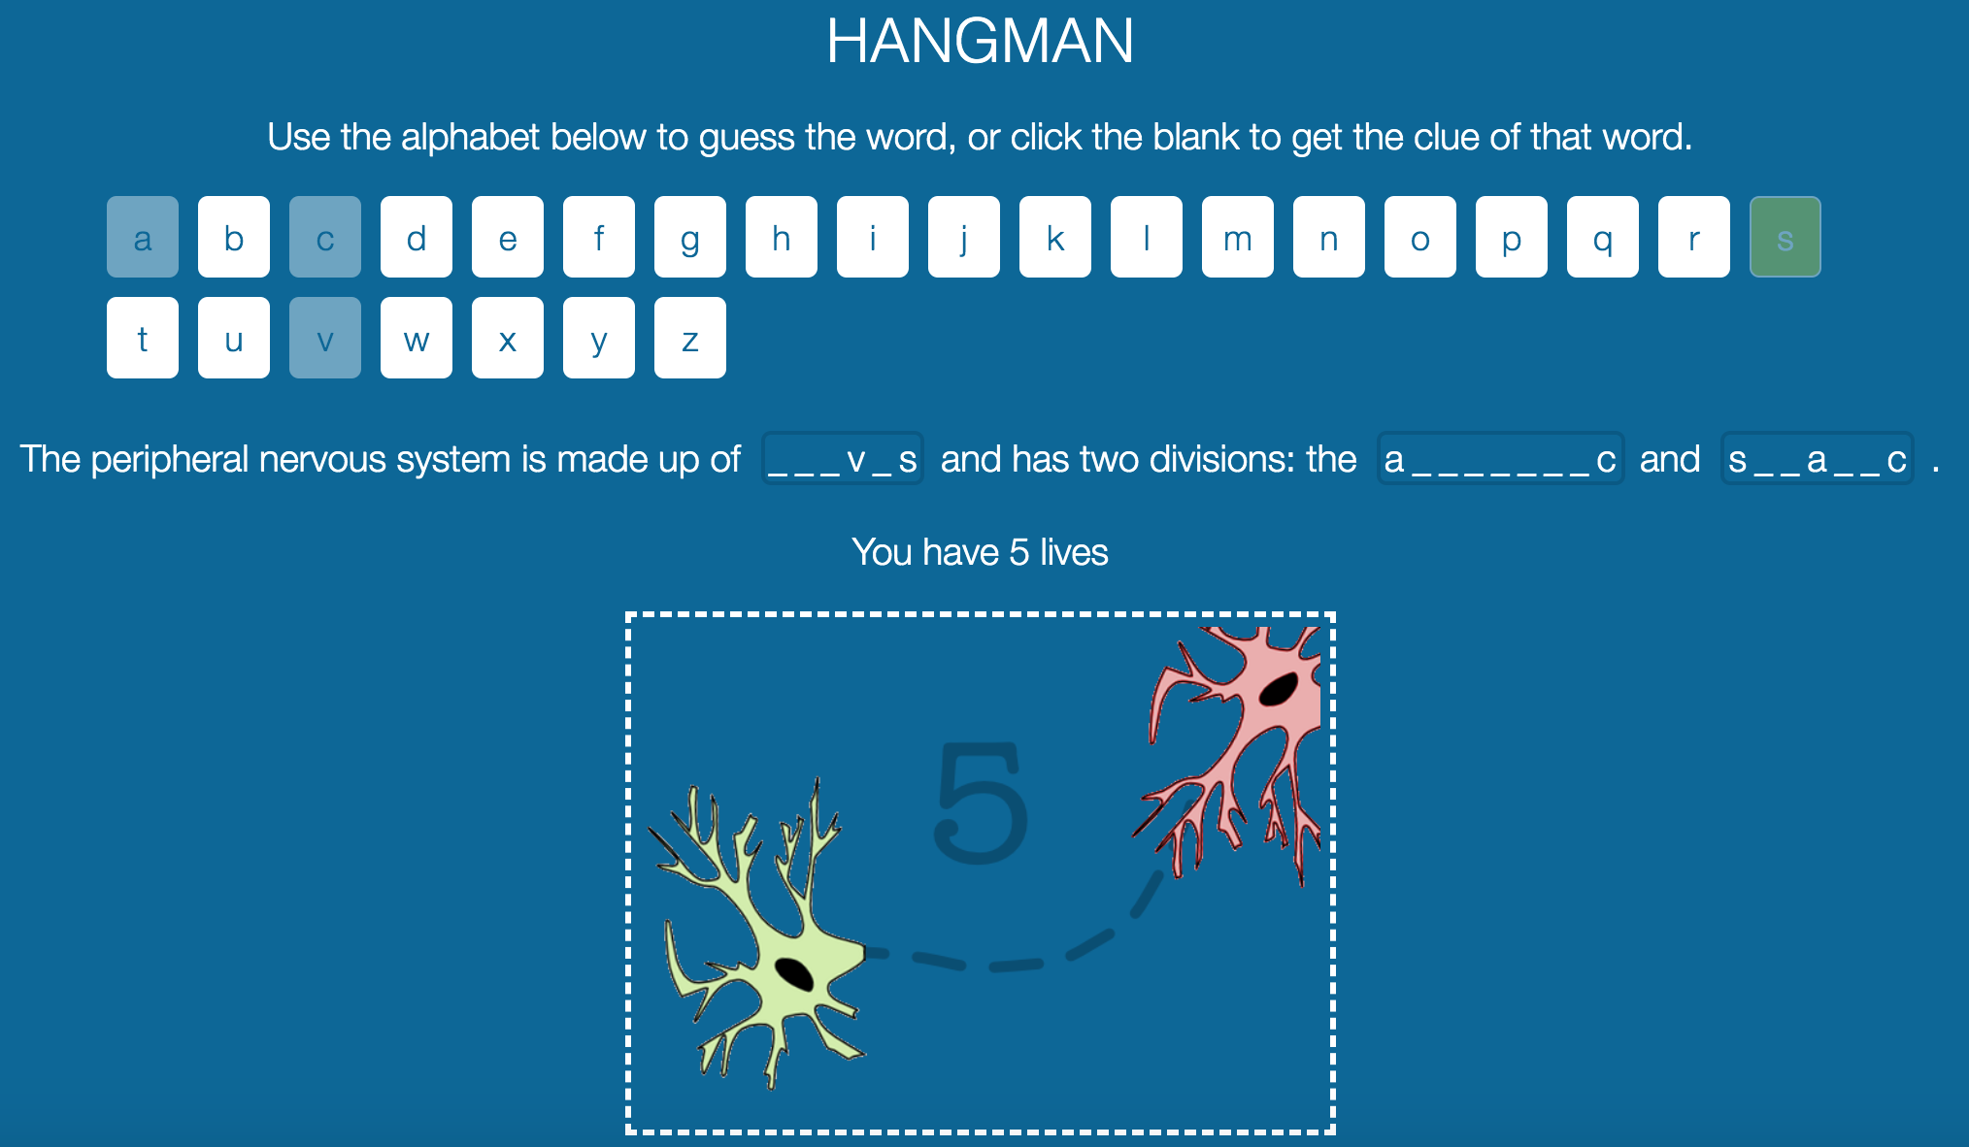

* 1. Changed the rule of the game from guessing a word per sentence into guessing multiple words per sentence.
  2. Deleted the ‘hint’ button. Instead, by clicking on place-holder of certain words, we get hints.
  3. Deleted the canvas drawing of the hangman game. Provided some stress learning hint pictures instead.

1. We fixed the bugs of hangman game from last iteration.
   1. The user can’t click on the alphabet button after winning the game, which would make the user come to the game over page.
   2. The user cannot click on the alphabet button after losing the game, which would make the website turn to the error page.

* Plan for the next iteration

1. Extract the words to be guessed, the corresponding hints and the related sentences, and put them into a file as configuration so that it can be modified according to the client’s needs and new rules.

2. Deploy the hangman game on the Stepstone development server.